# **Doctor Appointment Booking System**

## Members Of The Project:

* 1702472 Ensar Buğrahan Erdağ
* 1730018 Doğuhan Elmas

## The aim:

Doctor appointment booking system consists of one database which contains all the necessary information about the patients such as the patient's first and last name and appointment date and the patient’s doctor name. This system allows the assistant to add the patients' data. This project is developed using Java. Linked List and Binary Search Tree data structures have been used during the development of the project. The assistant can display the information of patient’s which are being stored in Linked List and Binary Search Tree or add a new one.

## The flow of the project:

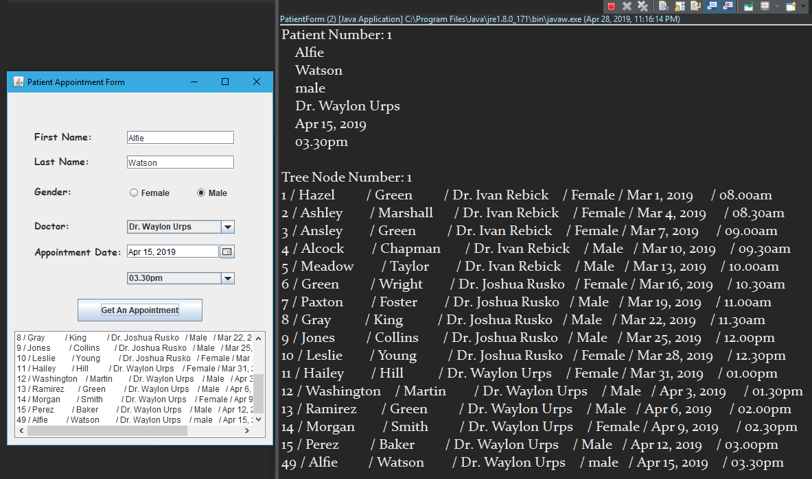

The assistant can fill the blanks with the patient’s information to arrange an appointment with the doctor. Once s/he clicks the “Get An Appointment” button, all the information of the appointments will be displayed on the listbox and the console tells him/her that the data of the patients is being stored on both linked list and binary search tree.

# **References**

<https://github.com/Zyrcant/LinkedListJava/blob/master/LinkedListProject2/src/linkedlistproject2/LinkedListIDedObjects.java>